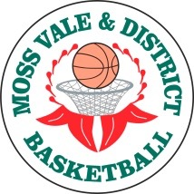
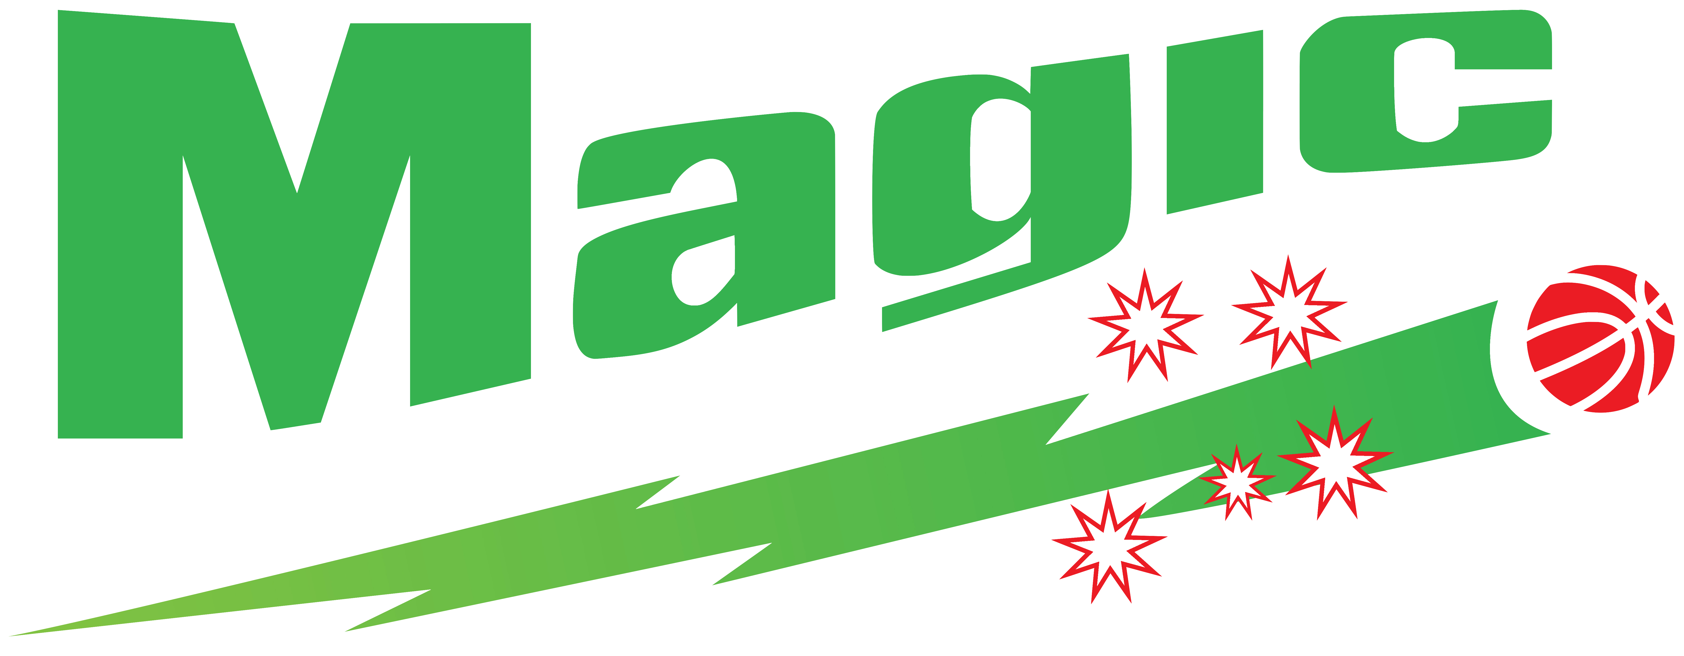

MOSS VALE & DISTRICT BASKETBALL ASSOC. Inc.
2027 REPRESENTATIVE PROGRAM
HEAD/ASSISTANT COACH APPLICATION FORM
Name:
Address:

Contact No:
Email:
Positions applied for:
(At least 2 preferences required in case your 1st choice is unsuccessful)
1st Preference: |  | Position: |  |  | Competition: |  |  |  | Age
2nd Preference: |  | Position: |  |  | Competition: |  |  |  | Age
3rd Preference:  4th Preference: |  | Position:  Position: |  |  | Competition:  Competition: |  |  |  | Age  Age
Mandatory for start of Leagues:  Do you have a current Club Coach (Level 1) accreditation?  Do you have a current Working With Children Check? |  |  |  |  |  |  |  | Cert No:  WWC Number:
Experience:
Have you Coached a Moss Vale Magic Representative Team before?
If Yes, Last Team Coached:
Season Results:
Other Coaching Achievements:
Signed: |  |  |  |  |  |  | Date:
APPLICATIONS CLOSE Monday 7 September 2026

